## PHASE 5: AUTOMATION FLOWS

**Flow Design & Configuration**

* Flow Name: Auto Assign Driver
* Object: Delivery
* Trigger: After Create (only when Status = "Scheduled")
* Optimization: Use “Actions and Related Records” mode

Flow Steps:

* Start (Delivery record created)
* Call Apex Action (NearestDriverService) with Delivery fields
* Decision: Check if a Driver was found
  + If Driver Found: Assignment → Update Delivery Record fields (Status, Assigned Driver, ETA, Distance)
  + If No Driver: End (no assignment)

Apex Action Inputs/Outputs:

* Inputs: deliveryId, latitude, longitude, hubId (from record)
* Outputs: driverId, estDistanceKm, estETAHours (to be used in assignments)

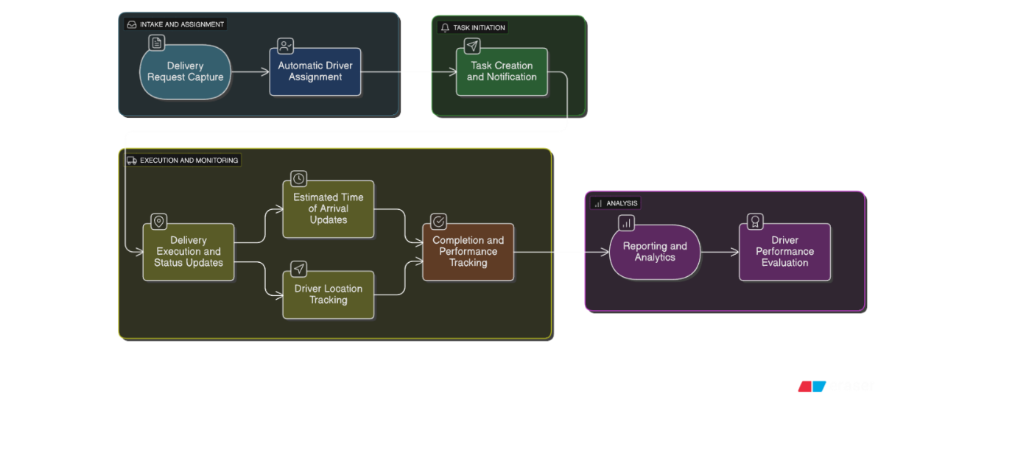

**Business Logic & Testing**

* Decision Element:  
  Checks if {!Find_Nearest_Driver.driverId} is not null.
  + If true, update fields & assign driver.
  + If false, do not update (no driver available).
* Assignment:
  + Status = "Assigned"
  + Assigned_Driver__c = output driverId
  + Estimated_Distance_km__c = output estDistanceKm
  + ETA__c = {!$Record.Scheduled_Date__c} + ({!Find_Nearest_Driver.estETAHours} / 24)
* Update Records:
  + Updates Delivery with newly assigned values

Testing Method:

* Create test deliveries with coordinates.
* Verify that Status, Driver, Distance, ETA are calculated & populated.
* Confirm graceful handling if no driver/coordinates available.

Error Handling:

* No available drivers: Flow ends (no error—record remains Scheduled)
* Missing/invalid coordinates: Apex error handling prevents crash
* Any system error: Use Flow debug/interview logs to review failure details

